Project Documentation
Import Data using Transform Maps (Spreadsheet) – ServiceNow

1. Introduction
- Project Title: Import Data using Transform Maps (Spreadsheet)
- Team Members:
Abinaya K
Gokila Subashini V
Gopika S
Akalya P
Karthika V

2. Project Overview
- Purpose: This micro project imports structured employee data from an external spreadsheet into the ServiceNow platform using Import Sets and Transform Maps. It simulates a real-world scenario where bulk employee data arrives in Excel format and must be migrated into ServiceNow efficiently and accurately. It helps beginners understand the end-to-end data import process: data loading, field mapping, transformation execution and result verification.
- Features:
  - Load employee data from an Excel spreadsheet (.xlsx) into an Import Set staging table.
  - Custom target table (Employee Test) with fields for Employee ID, Employee Name, Email, Department and Location.
  - Transform Map with Auto Map Matching Fields and Mapping Assist for field mapping.
  - Coalesce on a field to update existing records instead of creating duplicates.
  - Transform History to verify inserted and updated records.

3. Architecture
- Frontend: ServiceNow web UI – Application Navigator, table/form layouts, list views (Personalize List Columns) and the Load Data module. No custom UI was developed.
- Backend: ServiceNow platform services – Import Set (staging), Transform Map (field mapping and transform execution) and Transform History.
- Database: Two tables are used: a staging table and a custom target table.

Table | Name | Purpose
Employee Import | u_employee_import | Import Set (staging) table that receives the spreadsheet data
Employee Test | u_employee_test | Target table where transformed employee records are stored

Fields in the Employee Test table (all of type String): Employee ID, Employee Name, Email, Department, Location.
Data flow: Spreadsheet (.xlsx) → Load Data → Import Set table (u_employee_import) → Transform Map → Target table (u_employee_test).

4. Setup Instructions
- Prerequisites: ServiceNow instance (e.g., Personal Developer Instance) with admin access; Google Sheets or Microsoft Excel to prepare the sample data; a web browser.

Phase 1: Prepare the Sheets
- Open a new Google Spreadsheet.
- Create the spreadsheet with the sample employee data as shown below.
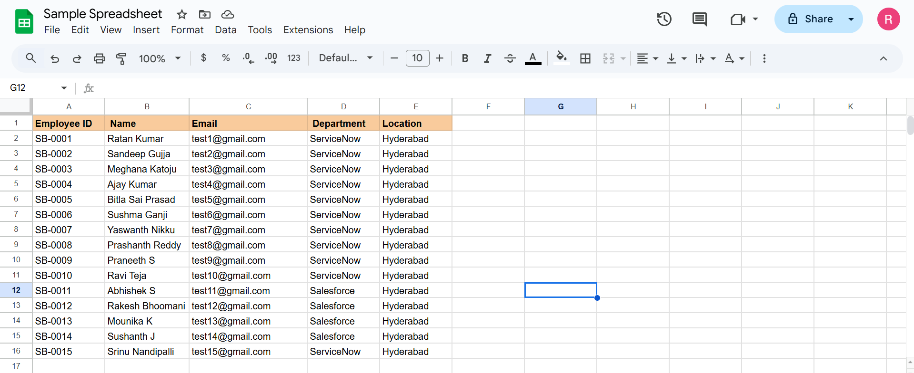
Sample employee data in the spreadsheet
- Download the spreadsheet in .xlsx format as “Sample Spreadsheet.xlsx”.
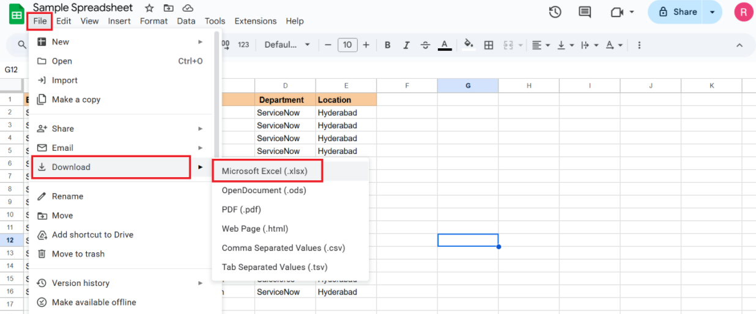
Downloading the spreadsheet as .xlsx

Phase 2: Create the Custom Table
Navigation: Tables > Create New
- Label: Employee Test
- Name: u_employee_test
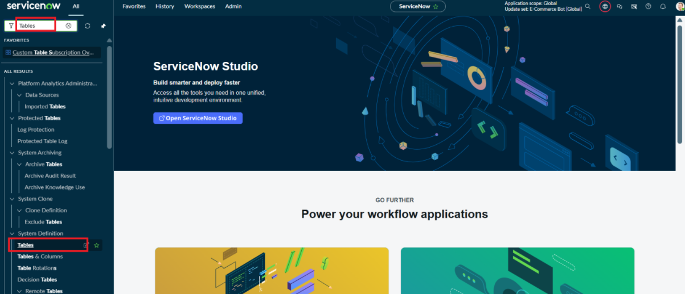
Creating a new table
- After creating and saving the Employee Test table, scroll down to the bottom of the table form.
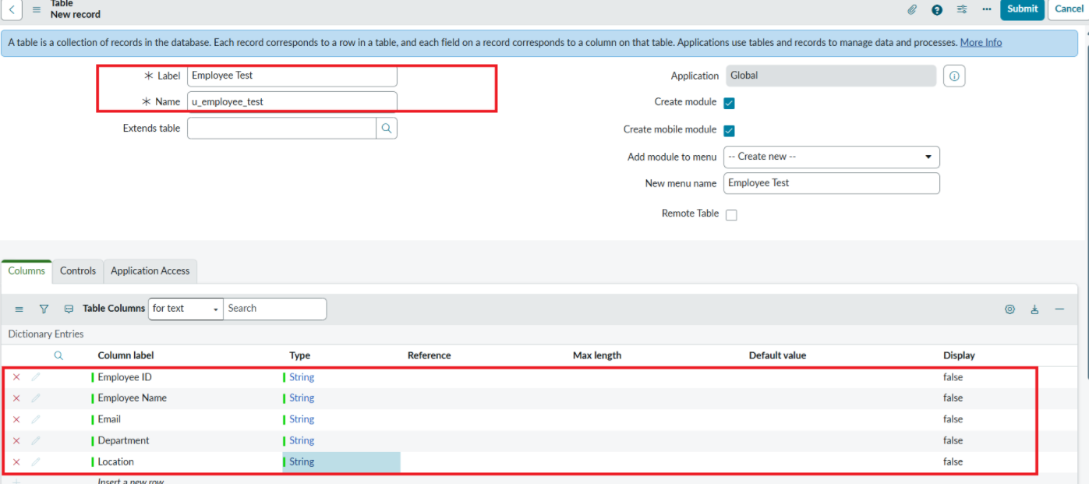
- Click Show Form to open the table form.
- Click the Form Context Menu / Additional Actions icon in the form header, then choose Configure > Form Layout.
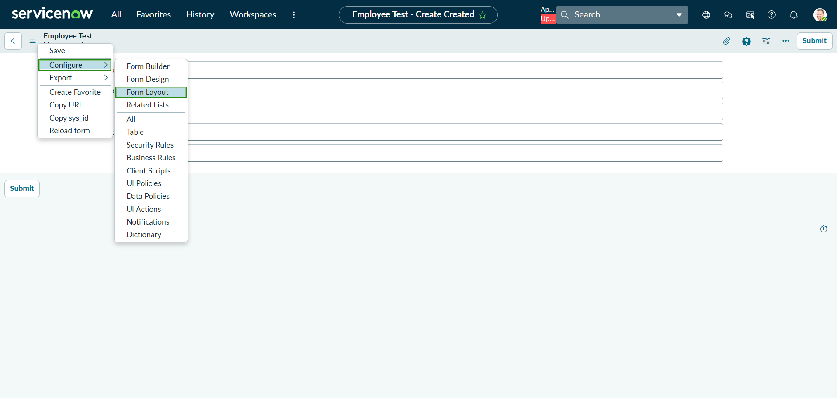
Opening Form Layout
- In Form Layout, click New to create a new field and enter the details: Column Label – Employee ID, Type – String. Click Add.
- Repeat the same steps to create the remaining fields (all Type – String):
  - Employee Name
  - Email
  - Department
  - Location
- Click Save and verify that the new fields appear on the Employee Test form.
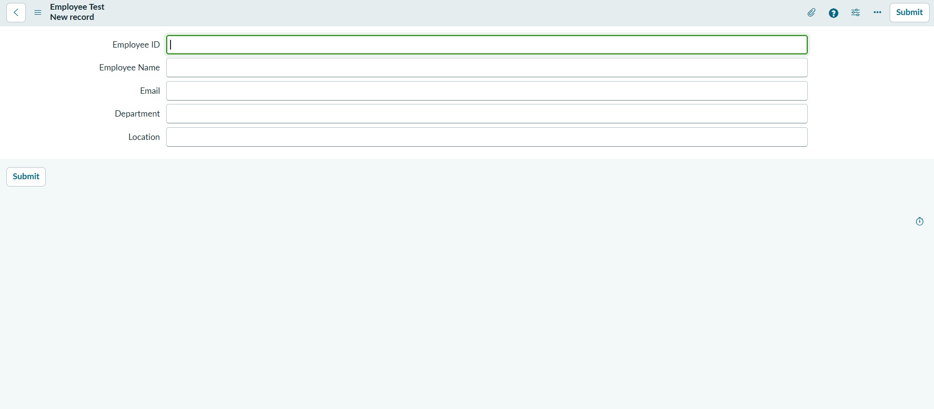
Employee Test form with the new fields

5. Folder Structure
This is a ServiceNow platform project, so there is no client/server code folder. The project is organised as the following platform components:
- Client (Source side): Sample Spreadsheet.xlsx – the source file containing employee data.
- Server (Platform side): u_employee_import (Import Set table) → Sample Spreadsheet Import (Transform Map) → u_employee_test (target table).

6. Running the Application
The import is run from the ServiceNow UI (no npm commands are required).

Phase 3: Import Set Table
Navigation: Application Navigator → Load Data
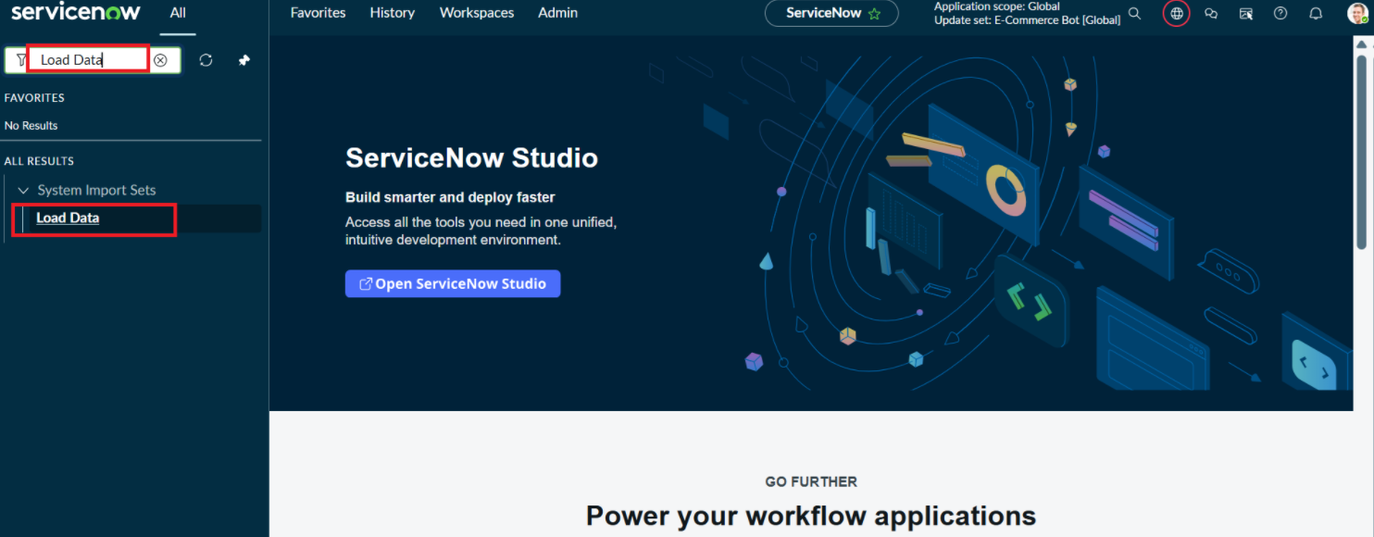
Load Data module
- Click Load Data and create an import table. Fill in: Label – Employee Import; Name – u_employee_import (auto-populated).
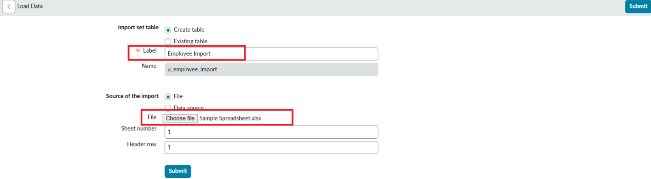
Import table details
- Click Submit. A success message is displayed. Make sure to click Create Transform Map.
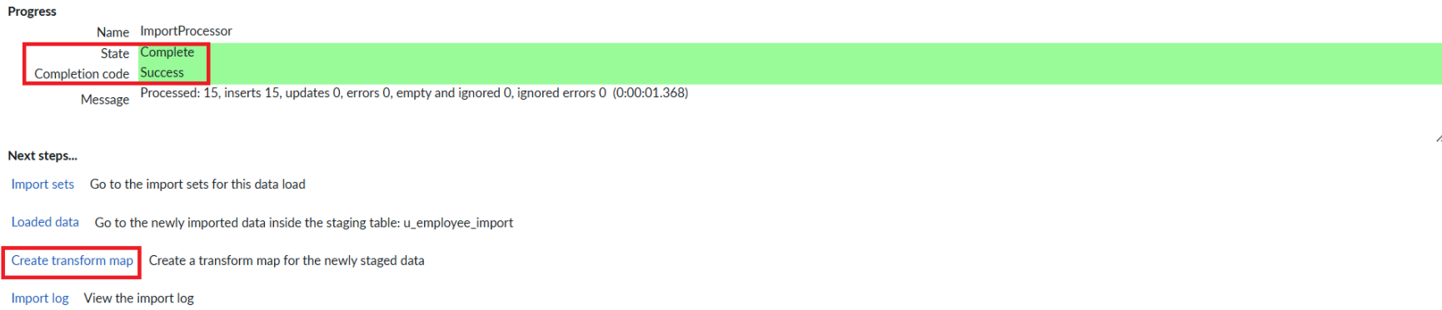
Success message and Create Transform Map option

Phase 4: Create the Transform Map
- Name: Sample Spreadsheet Import
- Source Table: Employee Import (auto-populated)
- Target Table: Employee Test (created earlier)
- Click Auto Map Matching Fields.
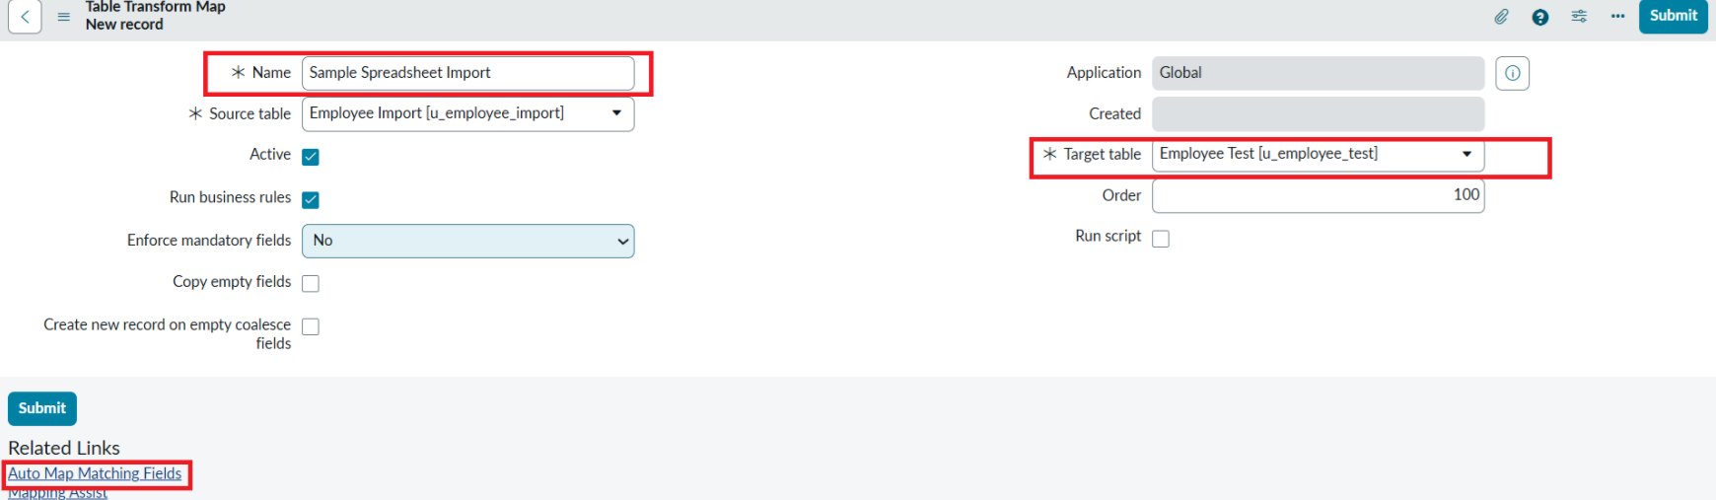
Transform Map details
- Click Mapping Assist and map the fields between the source and target tables, then click Save.
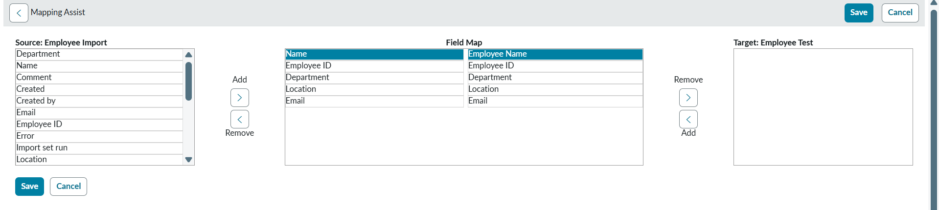
Mapping Assist
- Make sure both source and target table fields are mapped as shown below.

Field mappings
- Click Transform.
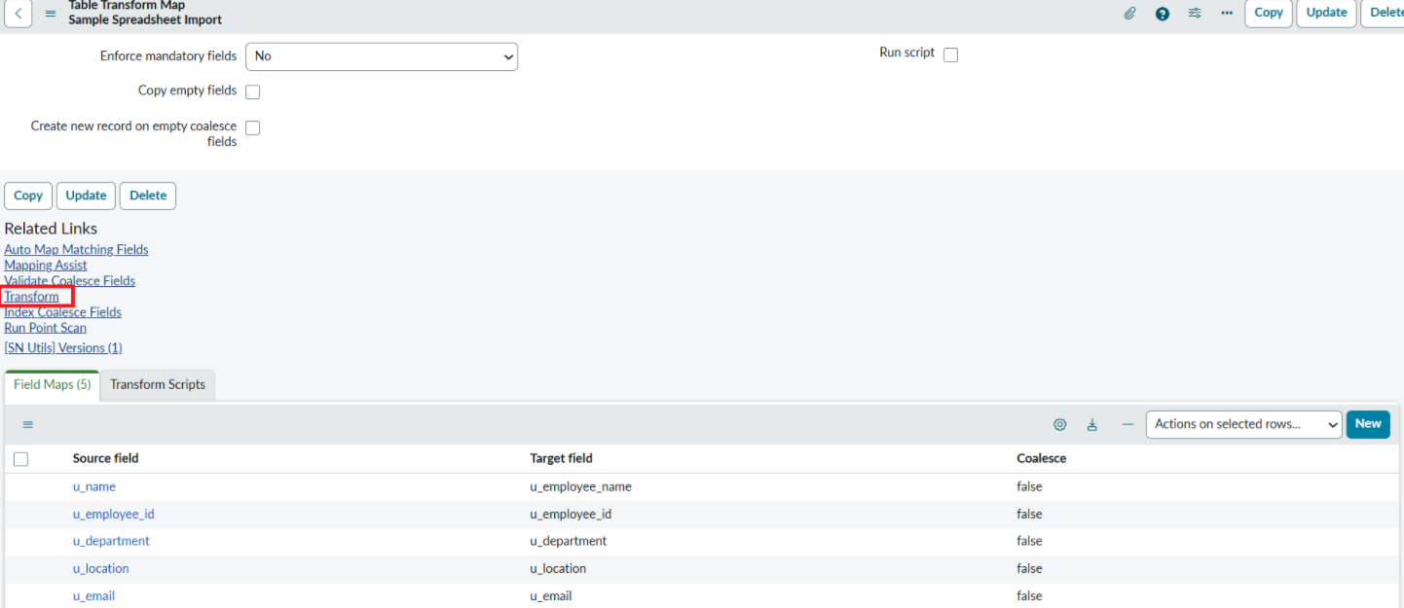
- Click the Transform button.
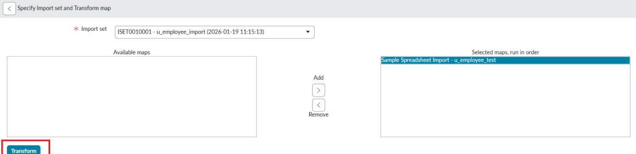
- After clicking Transform, make sure the success message appears.

Transform completed successfully

Phase 5: Transform Data and Validate
- Open the Employee Test table from the Application Navigator.
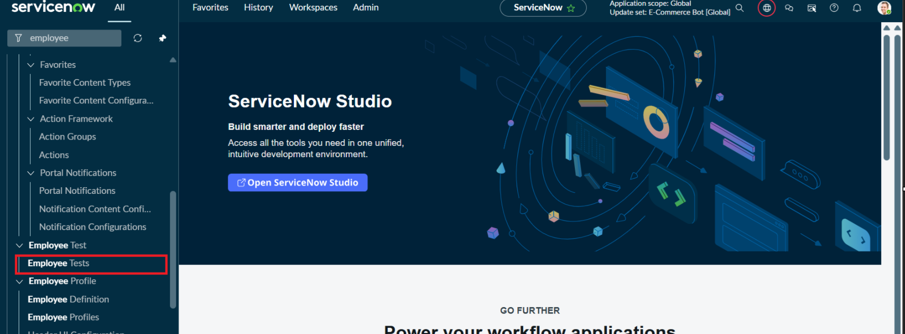
- Since the import succeeded, all records are created in the Employee Test table.
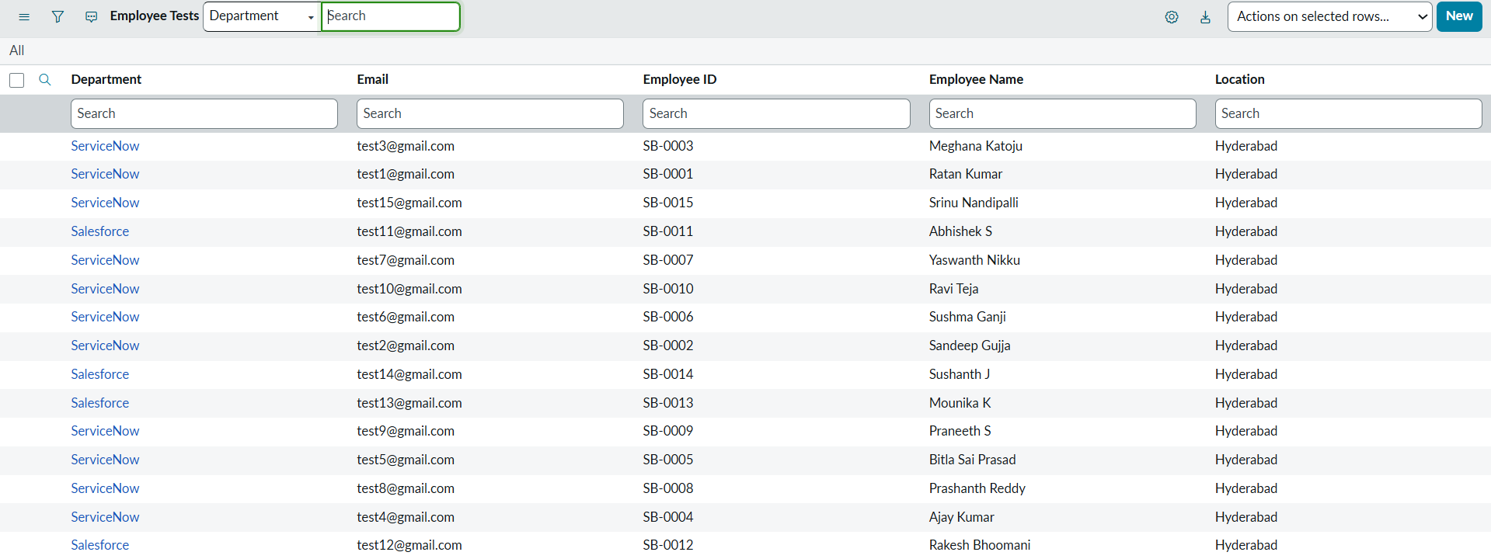
- Rearrange the columns using Personalize List Columns, then click OK.
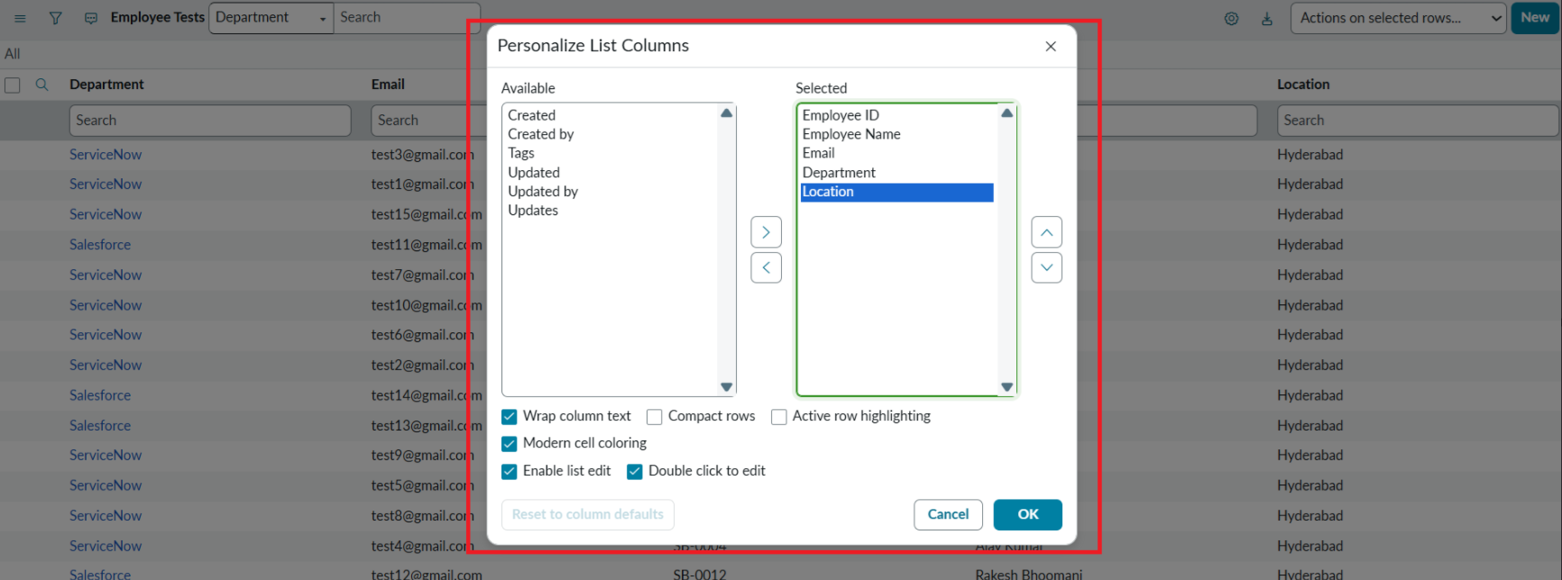
Personalize List Columns
Final Result: All records are successfully imported into ServiceNow using the Import Set and Transform Map.

Imported records in the Employee Test table

7. API Documentation
Not applicable. No custom REST API endpoints were developed in this project. Data is loaded through the ServiceNow Load Data module and processed by the Transform Map.

8. Authentication
Authentication and authorization are handled by the ServiceNow platform itself. Users log in to the ServiceNow instance with their credentials, and an admin role is needed to create tables, Import Sets and Transform Maps. No custom authentication was implemented.

9. User Interface
The following screens showcase the main UI of the project.
Employee Test form
Transform Map field mappings
Employee Test list after import

10. Testing
Testing was done manually by importing data, running the transform and verifying the results in the target table.

Test 1: Initial import
- Sample data was loaded, transformed, and all records appeared in the Employee Test table (see Phase 5).

Phase 6: Enable Coalesce to Avoid Duplicate Records
- In real projects, the same employee data may be imported multiple times. Coalesce prevents duplicate records: existing records are updated with new values and duplicates are not inserted.
- Steps:
  - Open the Transform Map under System Import Sets (All menu).
  - Open the created Transform Map – Sample Spreadsheet Import.
  - In the Field Maps related list, set Coalesce to true for one field that currently shows false.
  - Save the form.
  - Add more data in Excel format and import it again.
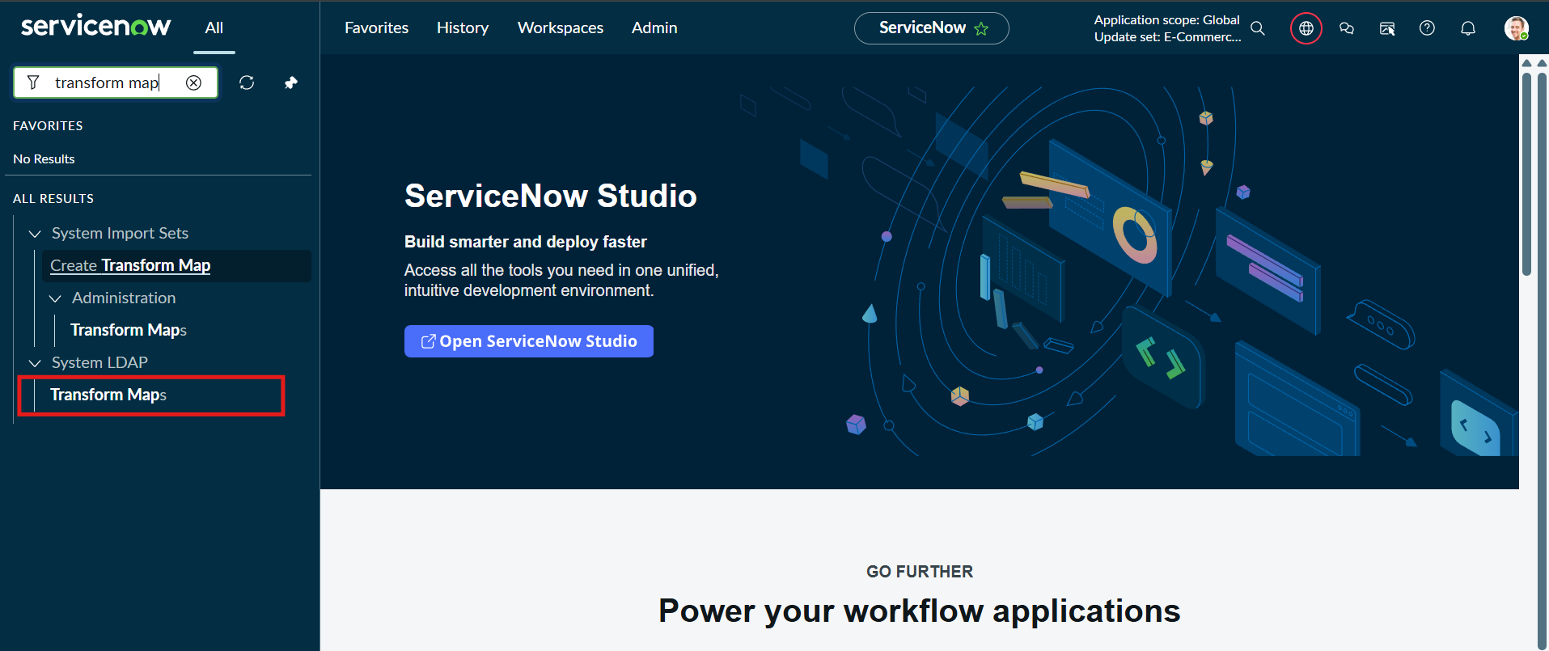
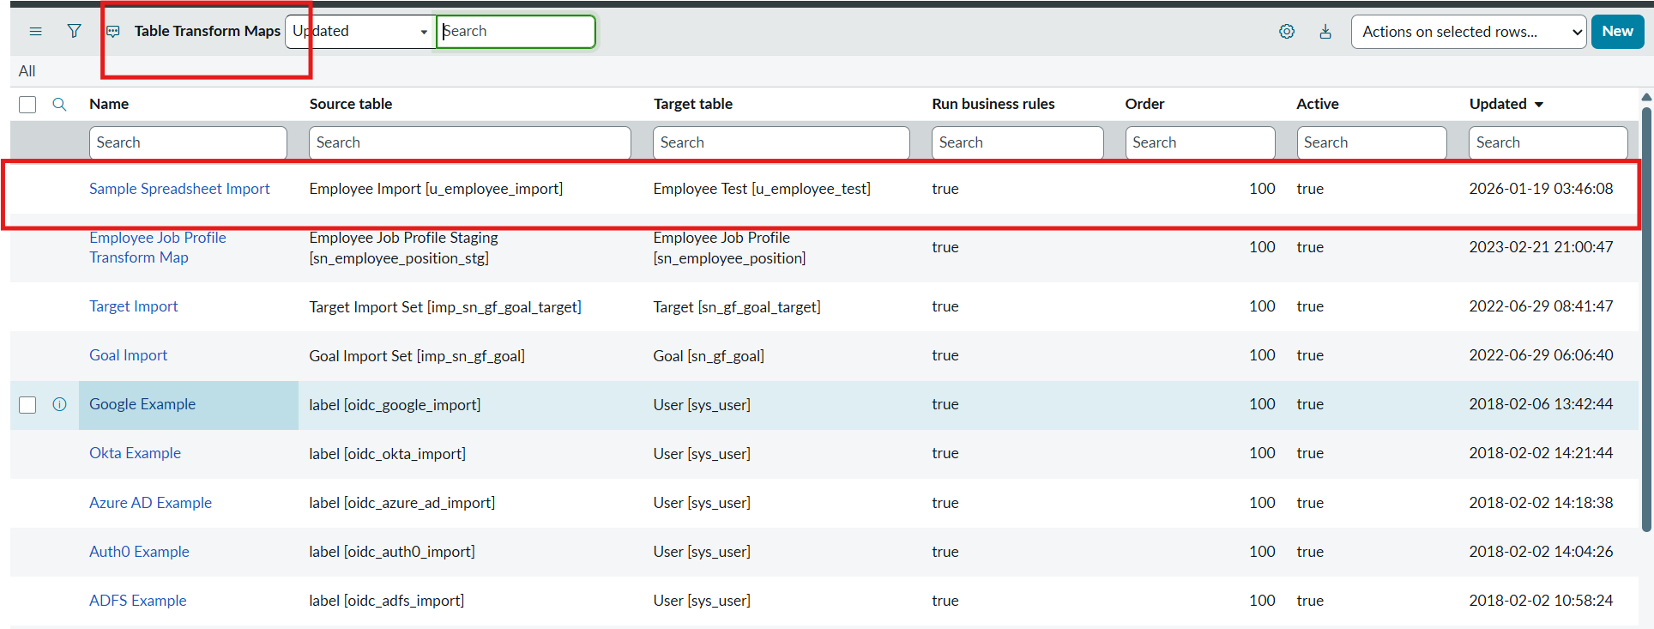
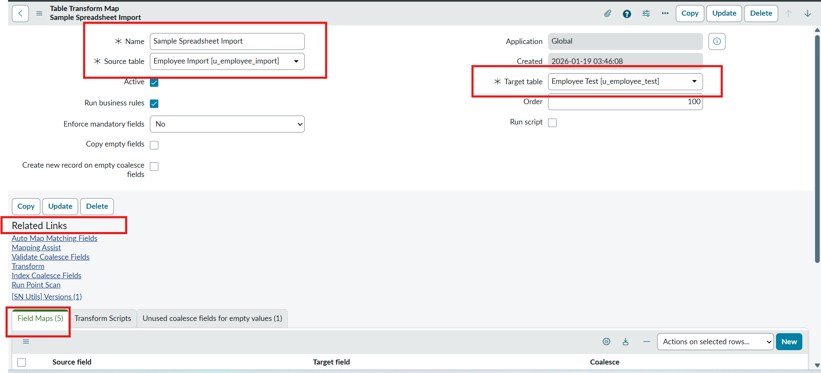

Enabling Coalesce on a field map

Phase 7: Inserting New Data in Excel Format
- Navigate to All menu, search for Load Data under System Import Sets and open it.
- Fill in the details: Import set table – Existing table (Employee Import); Source of Import – File (choose the file); Sheet number – 1; Header row – 1. Click Submit.
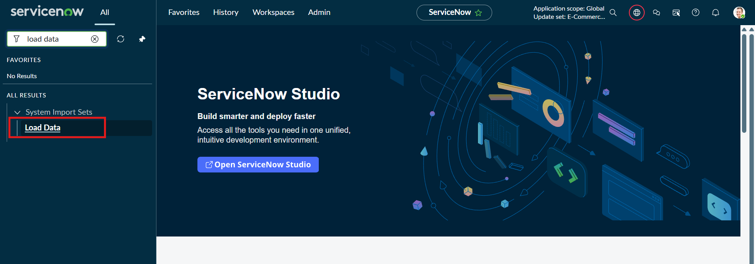
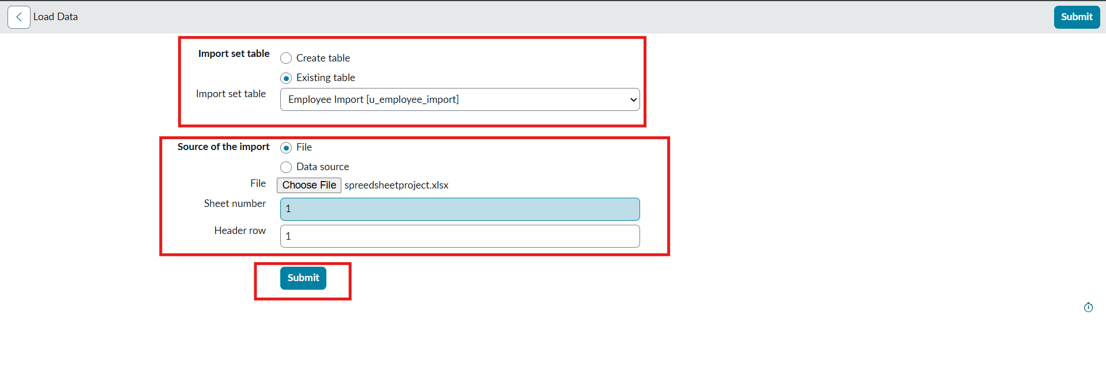
- The newly created Excel data:
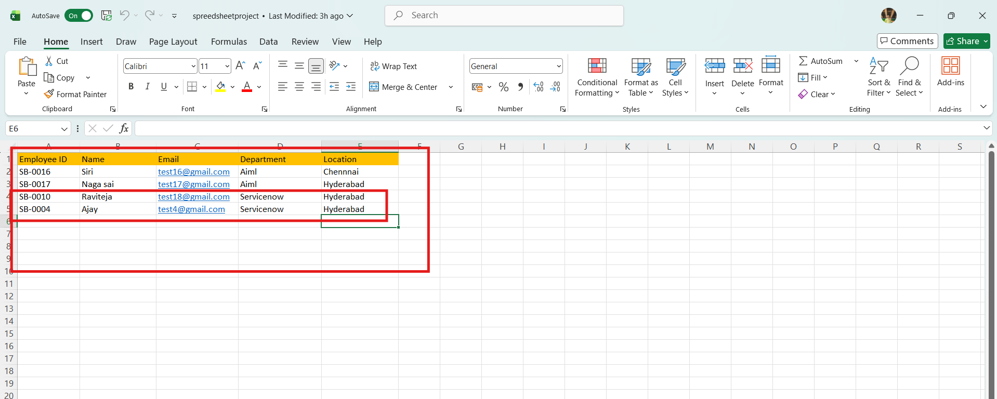
New Excel data
- The previously added data:
Previous data
- In the new data, 4 rows were added: 2 rows with existing Employee IDs but changed values, and 2 completely new employees.
  - Raviteja’s email was changed from test10@gmail.com to test18@gmail.com.
  - Employee ID SB-OOO4: name changed from Ajay kumar to Ajay.
  - Two new Employee IDs were added.
- After submitting the form, the state shows Completed and Success.

Import Set state: Completed / Success
- Click Run Transform under Next steps. The previously selected Transform Map is shown; click the Transform button.
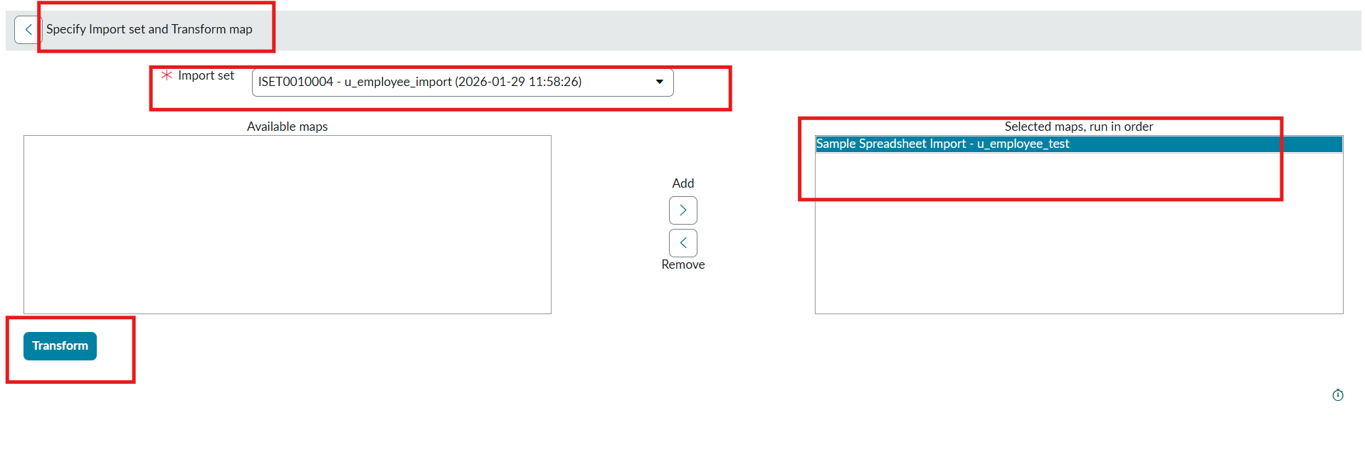
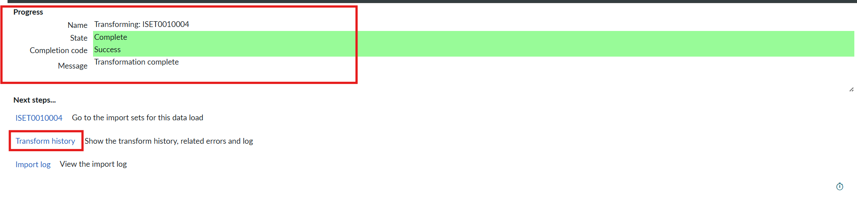
- The state shows Completed and Success.
- Open Transform History to see the Inserted and Updated status of the rows.

Transform History
Result: Out of 4 uploaded rows, 2 were inserted (the two new IDs) and 2 were updated (same IDs with changed name and email). Open the Employee Test table to verify the inserted and updated rows.

11. Screenshots or Demo
Demo link: [fill this – add demo video / link if available]
Final result – records imported into Employee Test
Transform History – Inserted / Updated counts

12. Known Issues
- Without Coalesce enabled, importing the same data again creates duplicate records.
- Auto Map Matching Fields works only when the spreadsheet column names match the target field names; other fields must be mapped manually using Mapping Assist.
- [fill this – add any other issues you faced]

13. Future Enhancements
- Add field validation and data cleanup (e.g., email format check) using transform scripts.
- Map Department and Location to reference fields instead of plain strings.
- Schedule automated imports using Scheduled Data Imports.
- Send notifications for failed or skipped rows.

